**EXPERIMENT 5**

**DDL COMMANDS (COLLEGE SCHEMA)**

**Aim:**

* Create a schema called College.
* Create tables for students (attributes: student id, name, gender, subject, marks and grade), faculty (attributes: faculty id, name, course and pass percentage), department (attributes: department id, name, section, strength and pass percentage) and activity (attributes: activity id, name, strength and category)
* Add and modify:
  + Address in students table, change datatype size of student name and make student id primary key
  + Add faculty total mentor details, make faculty id as primary key
  + Add number of students in wise in department table and make department id as primary key
  + Add faculty name to activity table, change the datatype size of activity name and make activity id as primary key

**Procedure:**

**Code:**

* **create schema College;**
* **create table student(studid integer, std_name varchar(50), gender varchar(10), subject varchar(20), marks integer, grade varchar(2));**
* **create table Faculty(fac_id integer, fac_name varchar(50), course varchar(10), pass_percentage integer);**
* **create table department(dept_no integer, dept_name varchar(20), section varchar(1), no_of_students integer, pass_percentage integer);**
* **create table Activity(act_id integer, act_name varchar(50), no_of_students_opted integer, category_of_activity varchar(50));**

**Verifying:**

**Student table**

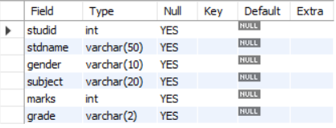

**Faculty table**

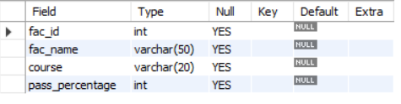

**Department table**

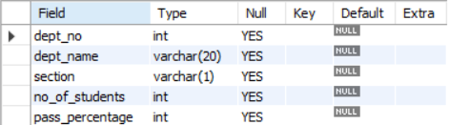

**Activity table**

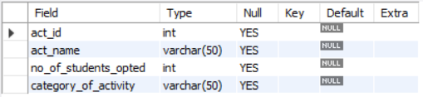

**Code:**

* **ALTER TABLE student add column address varchar(100);**
* **ALTER TABLE student modify stdname varchar(40);**
* **ALTER TABLE student add primary key (studid);**

**Verifying:**

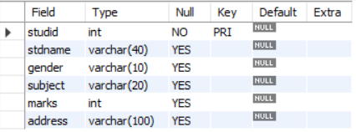

**Code:**

* **ALTER TABLE faculty add(fac_mentor_details varchar(30), primary key(fac_id));**

**Verifying:**

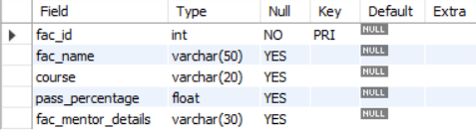

**Code:**

* **ALTER TABLE department add(no_of_studs_in_wise int, primary key(dept_no));**

**Verifying:**

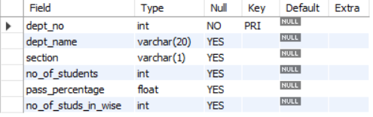

**Code:**

* **ALTER TABLE activity add faculty_name varchar(50);**
* **ALTER TABLE activity modify act_name varchar(10);**
* **ALTER TABLE activity ADD primary key (act_id);**

**Verifying:**

